(Approx. 1702 words)

Digital Camera Control and Image Capture
By Dick Maybach, Member, Brookdale Computer Users Group, NJ
May 2018 issue, BCUG Bytes
www.bcug.com
n2nd (at) att.net

My April 2018 article discussed what digital cameras do. Before I left the house, I selected the film, matching its sensitivity to the light levels I expected, and choosing either color or black-and-white. For each picture I had to gauge the brightness, either by guess (with black-and-white film) or with an external light meter (with color) to set the aperture and shutter speed. Then I would estimate the distance to the subject and adjust the focus. At last, I was ready to push the button. Now these adjustments are controlled by the camera’s processor and made in a fraction of a second.

Sensor Sensitivity
Conventional film comes in different sensitivities for different purposes, with lower sensitivity providing finer grain but requiring more light. Likewise, digital cameras have an ISO rating indicating their level of sensitivity to light. Here too, lower ISO implies less noise but requires more light. The lowest ISO for most cameras is around 100 and can be increased in as high as several thousand, but very high ISOs often result in unacceptable noise; see Figure 1.

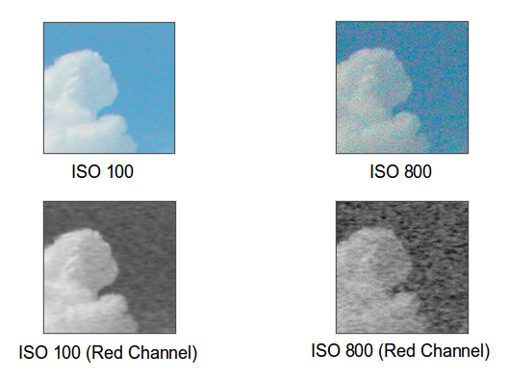
Figure 1. ISO Value and Noise.

Auto-exposure
Auto exposure is the process the camera uses to set its aperture and shutter speed, and most cameras let you select the mode, Figure 2. Matrix looks at the brightness of the entire frame, or at least at samples scattered about it, and is usually the right choice. The algorithms can be quite complex, and some high-end digicams hold databases of thousands of patterns, which they compare to the current image before setting the exposure. In unusual situations, you may wish to limit the area considered, for example if only the subject is brightly lit. In extreme cases, the area considered can be as small as five per cent of the frame area. Using the latter two modes, requires more time and thought, and in my experience often results in a missed picture.

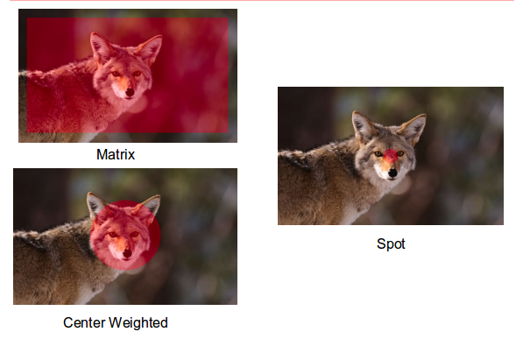
Figure 2. Auto exposure Modes.

When using electronic flash, some cameras either measure the amount of light returned from the subject when the flash is on and turn off the flash when they judge the exposure is correct or measure the returned light during a brief pre-flash.

Auto focus
Two common method of adjusting focus are contrast detection and phase detection. Contrast detection determines the distance to the subject by analyzing the image itself. The camera examines a small portion of the scene (shown by the red rectangles in Figure 3) and moves the lens elements, searching for the best focus. The processor in the camera measures the differences in intensity among the adjacent pixels in the strip. If the scene is out of focus, adjacent pixels have very similar intensities. The microprocessor finds the point that produces the maximum intensity difference between adjacent pixels; that's the point of best focus. Look at the difference in the pixels in the two red boxes in Figure 3; The intensity differences in between adjacent pixels are greater in the focused image on the right.

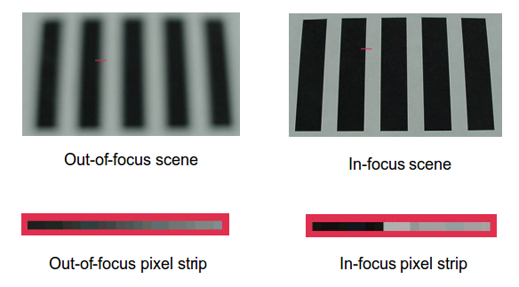
Figure 3. Contrast Detection Auto focus.

The image must have some detail and must be illuminated to provide the contrast that passive auto focus needs. If you try to take a picture of a blank wall or a large object of uniform color, the camera may not be able to find enough difference in adjacent pixels to adjust the focus. Although some systems react only to vertical or horizontal detail, newer designs use combinations of vertical and horizontal sensor strips.

This method is used on compact and mirrorless digital cameras. Early implementations were fairly slow, since the camera must search for the correct focus by moving the lens, but recent versions are much faster. Contrast detection requires no added hardware, since the input is from the existing photo-sensor (assuming of course that the sensor is not blocked by a shutter or mirror). Years ago, some cameras used active auto focus, which bounced sound from the subject and used transit time to judge distance. This worked well for subjects within 20 feet or so but required additional hardware. These techniques were more popular in film cameras; Polaroid in particular was fond of it.

Most single-lens reflex cameras use an auto focus method called phase detection, shown in Figure 4. (If you have an engineering background, be careful here; this method is not related to the one of the same name used in radio receivers.) There are two light paths, shown by the red and green lines. Using optics to separate the two, this system produces two images, one from the right and one from the left side of the lens. It then measures the distance between those two images and detects the defocus amount. As the subject moves closer or farther, the angles of these two beams change, causing the distance between the images to change. If the camera knows the lens characteristics, it can calculate exactly how far to move the lens to achieve correct focus from the separation of the images, making focusing extremely fast.

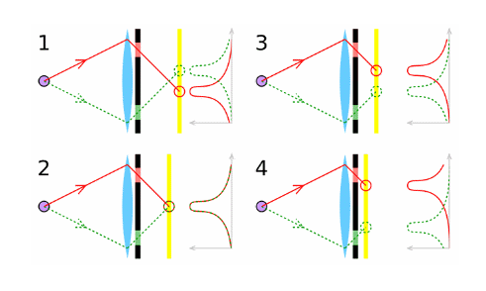
Figure 4. Phase Detection Auto focus.

This method judges distance the same way you do with your two eyes, but the separation in the camera is limited by the lens diameter. Hence, it's less effective with small lenses. Traditionally this method requires dedicated focus sensors. Initially, it was practical only for SLRs, but recently manufacturers have integrated phase detection into the main sensor, allowing its use in other architectures.

Figure 5 shows a traditional SLR phase detection sensor. It contains element pairs, some separated horizontally, some vertically, and some diagonally. There are optics between it and the lens so that each member of the pair sees the same portion of the image, but from a different position. Think of them as pairs of eyes, each looking at the same area. It's important to remember that you can't determine from its position on the sensor what portion of the image each pair sees. Here we see 10 pairs separated vertically, 10 diagonally, and 16 horizontally. Those separated horizontally look for vertical edges, and those separated vertically look for horizontal ones. We could use the sensor of Figure 5 to look for horizontal, vertical, or diagonal edges at 10 different areas in an image, and for vertical ones at an additional 6 areas.

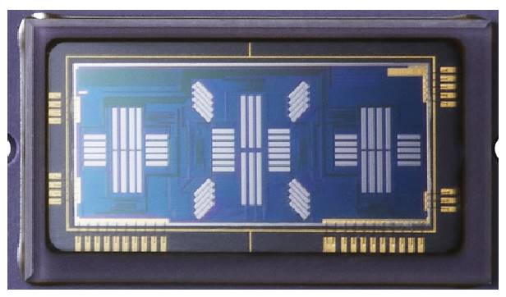
Figure 5. Phase Detection Sensor.

Figure 6 shows a complete phase detection auto focus system as implemented by an SLR.
- 1 is the object and the red lines show the light from it.
- 2 is the main SLR mirror, which is partially silvered to allow some light to pass through.
- 3 is the secondary mirror, which directs light to the focus system.
- 4 is the image sensor and shutter.
- 5 and 6 are mirror adjustment points.
- 7 is the phase detection sensor assembly, with the sensor itself at the bottom. The assembly contains masks and lenses to select and focus the light seen by each element of the sensor.
- 8 is the pentaprism that orients the viewfinder image. Without this the image would be upside down or reversed left-to-right.
- 9 is the viewfinder window.

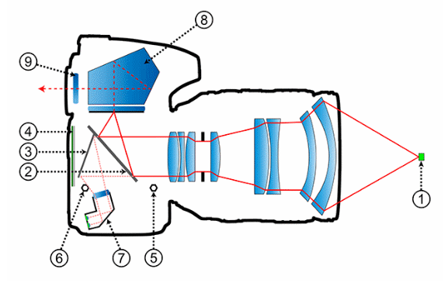
Figure 6. Complete SLR Phase Detection Auto Focus System.

The details aren't important. What is important is the concept of comparing an image as seen from two separated points to judge its distance. In the graphic, the top light path views the object from the top of the lens, and the bottom path from its bottom. This doesn't show the exposure system, which could be located at the bottom or in the viewfinder.

Image Capture
Once the camera has completed its exposure and focus adjustments it is ready to capture an image, which it does using a format designed to make the sensor’s job easier. Modern digital cameras contain more CPU power than desktop PCs of just a few years ago, and they have the power to convert these two forms that portray images correctly.

Digitizing
An Analog to Digital Converter (ADC) converts analog voltages to digital numbers. A one-bit ADC would classify the pixel values as either black (0) or white (1). A two-bit ADC would categorize them into four groups: black (00), white (11), and two gray levels in between (01 and 10). Most consumer digital cameras use 8-bit ADCs, allowing up to 256 distinct values for the brightness of a single pixel. Digital SLR cameras have sensors with a higher dynamic range and are usually equipped with 12-bit or higher ADCs. In each case, level 0 represents black, while the top (all ones) level represents white, and each intermediate level is a different shade of gray. These black, white, and gray brightness levels are all combined in what constitutes the gray-scale or brightness range of the image. A higher number of gray levels corresponds to greater bit depth and the ability to accurately represent a greater signal dynamic range, as shown in Figure 7.

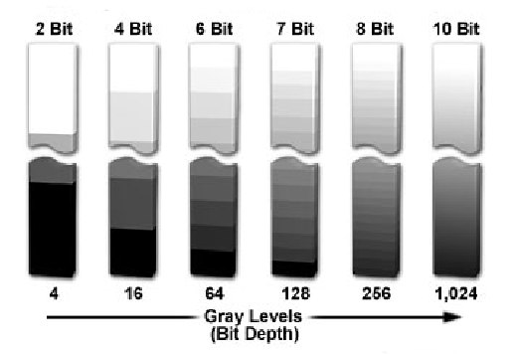
Figure 7. Bit Depth and Gray Levels in Digital Images.

Figure 8 shows the same black and white image using three different bit depths. The first uses just one bit to describe each sample, so each pixel is either black or white. Four bits per sample in the second image provide sixteen different shades of gray. This does not give a high-quality image, note the banding in the sky area. The third image uses eight bits to describe each sample. This allows each sample to take one of 256 possible gray values.

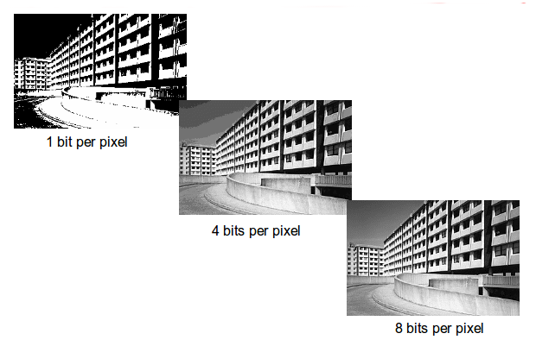
Figure 8. Gray Levels.

But what about color? Recall from the March 2018 article that the sensor is covered by a Bayer filter, which means that some pixels see only green, some only red, and some only blue. As a result, the camera can estimate not only the light intensity, but also the color at each pixel by using information from adjacent ones.

The processes we’ve discussed so far capture images that are properly focused and exposed, converts them to an array of digital numbers, and stores them. However, there is much to be done before they can be viewed, and I’ll discuss that next month.

